Latest News

Thursday 31 January 2013

From: Christina Fonfe

Received by: Email

We’re Going Surfing

A very kind generous surfing guest from Easy Beach Guest House showed a keen interest in what I was trying to achieve here in Sri Lanka with the Project. Jonny, a family man himself, volunteered to take the Project's swimming teachers, plus the Easy Beach chef, to Weligama Bay and give them their very first surfing lesson.

Dinusha has been teaching swimming with us for 7 years, first as a Student Swimming Teacher then qualified as a Swimming teacher. Indu learned to swim post-university and progressed from a complete non-swimmer to a swimming teacher in less than a year, while Sanduni has been with the Project since she was 16 and was home on leave from her swimming and lifeguarding job in Abu Dhabi.

There was great excitement as the girls were about to try out a new water sport. Going from non-swimmer to qualified swimming teacher followed by learning to surf was their dream come true.

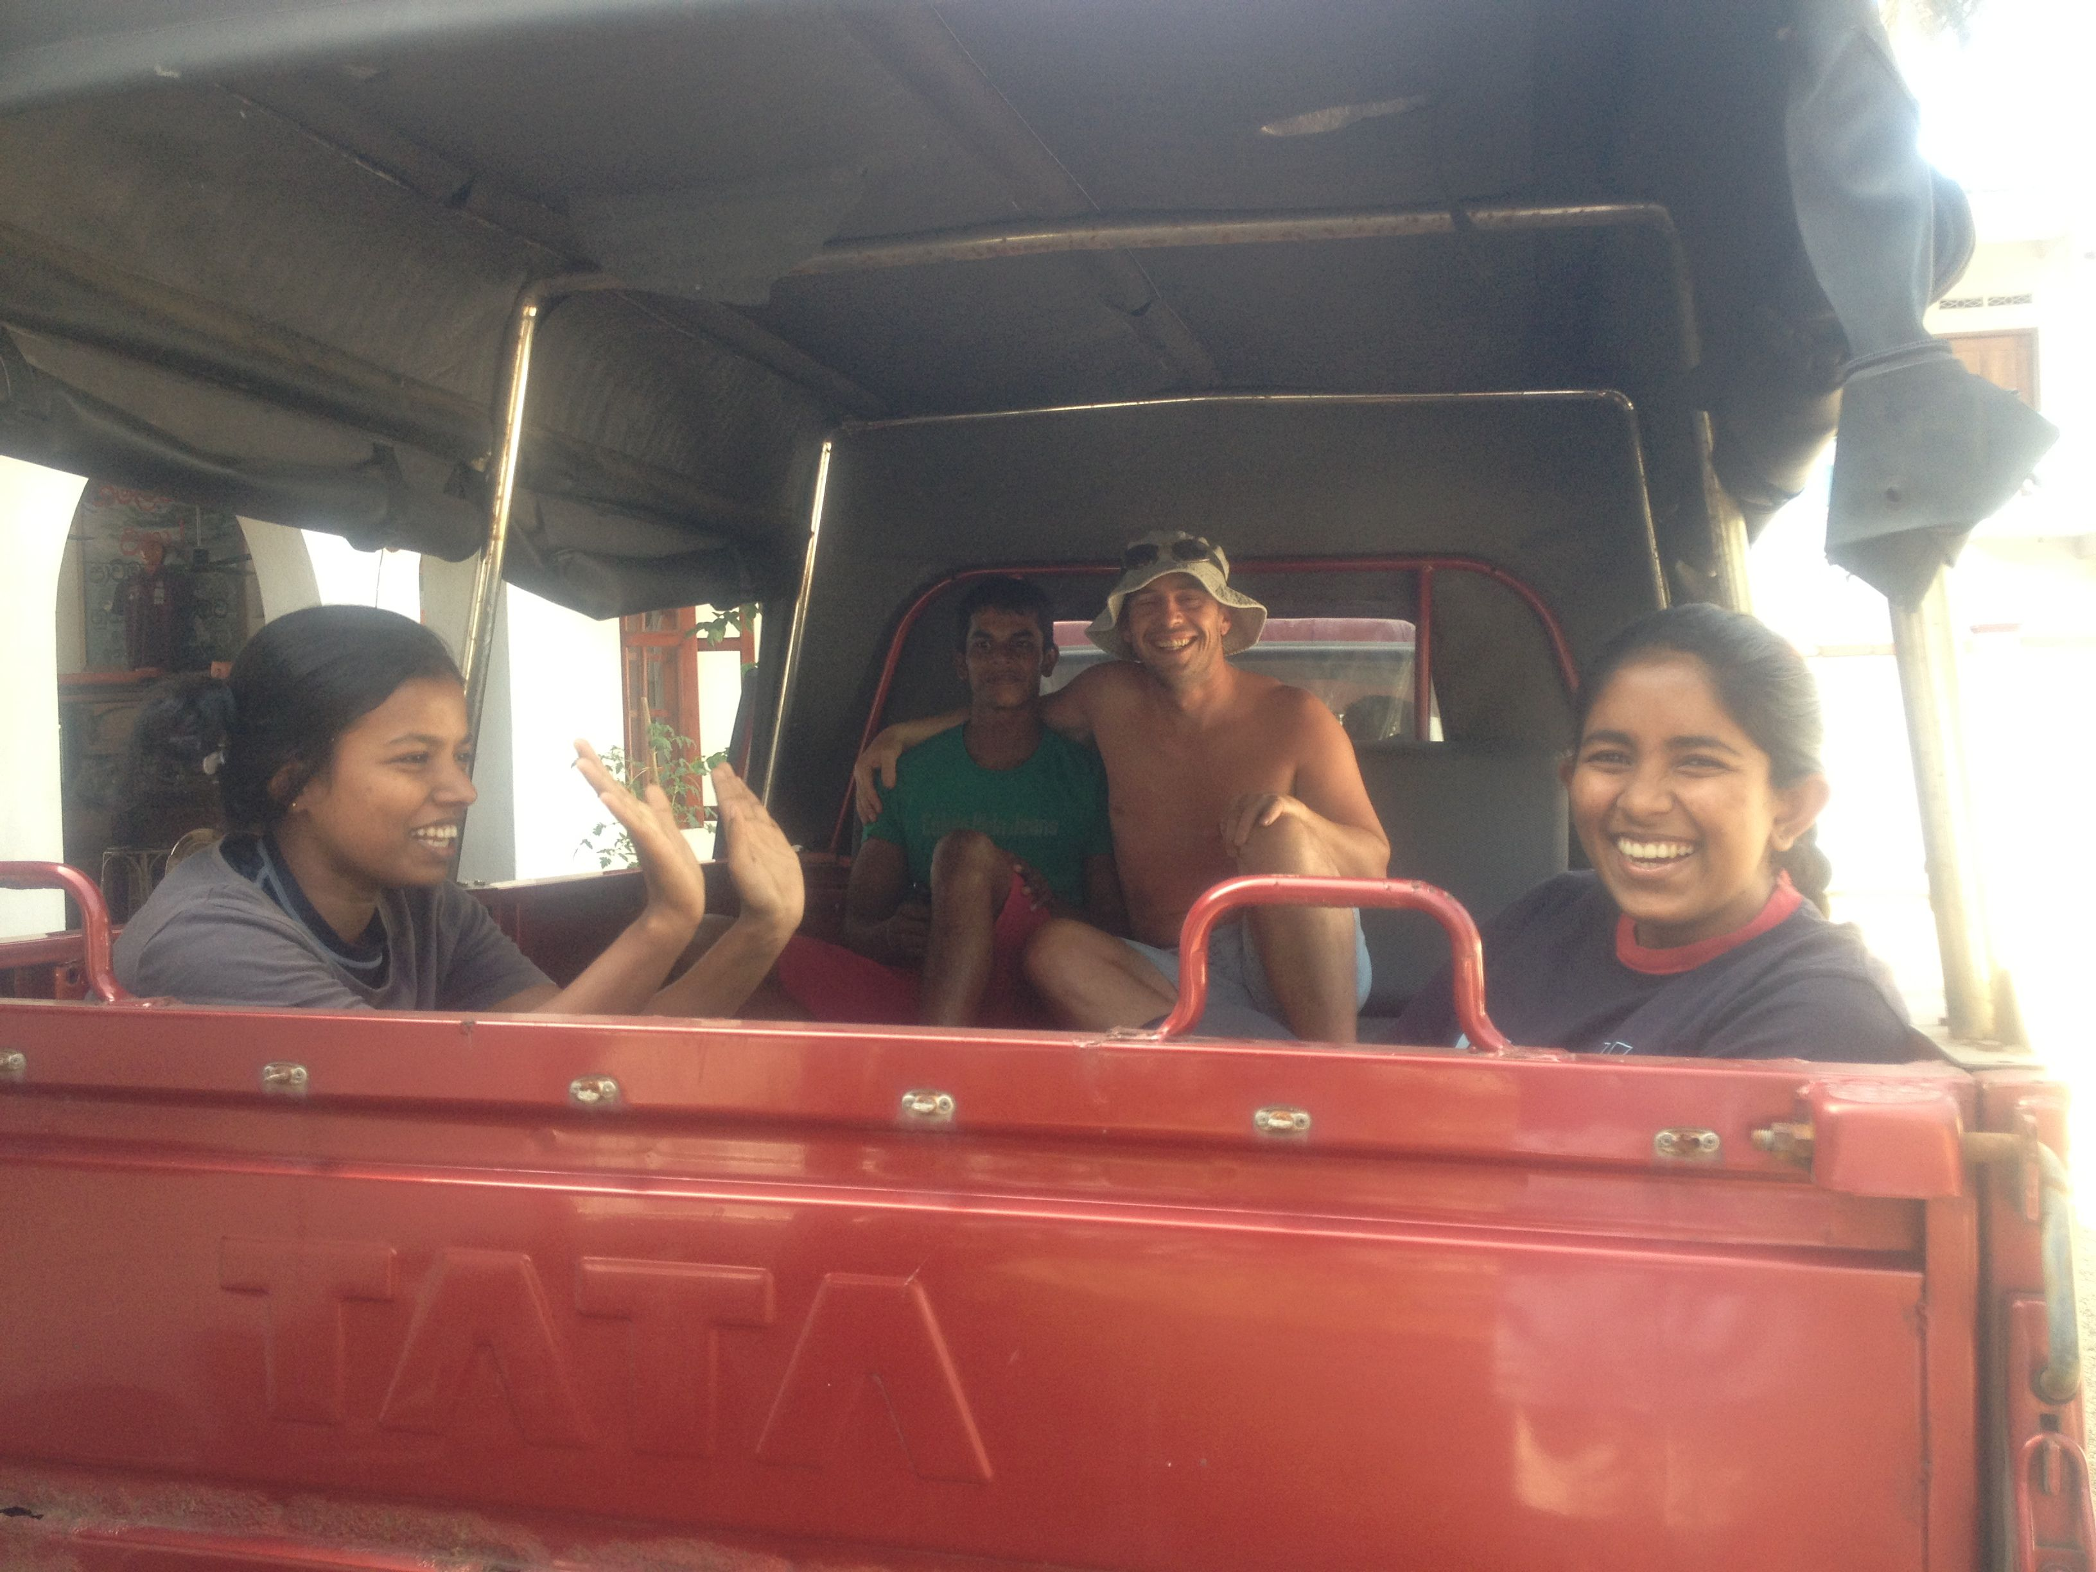
How else to arrive at the beach for some fun?

So, with great excitement, they piled into our pick-up truck – and off to Weligama By the end of their first lesson with Jonny , they had all managed to successfully ride a wave standing up. Thank You so much, Jonny. Bring your family and return again soon.

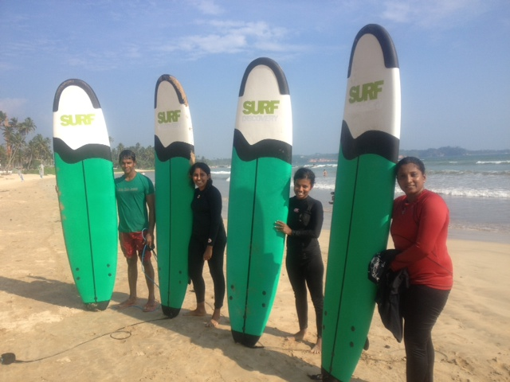
Swimming teachers Dinusha, Indu and Sanduni with Easy Beach chef Supun (in green) at Weligama Bay

Learning to swim has opened up many fun opportunities.

